

**2.5” Thermal Controller Build guide**

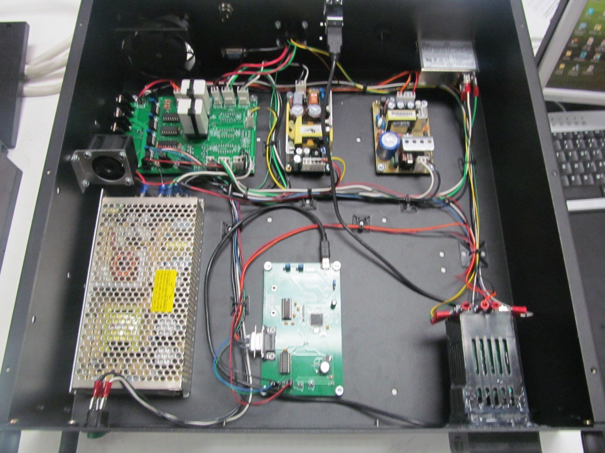

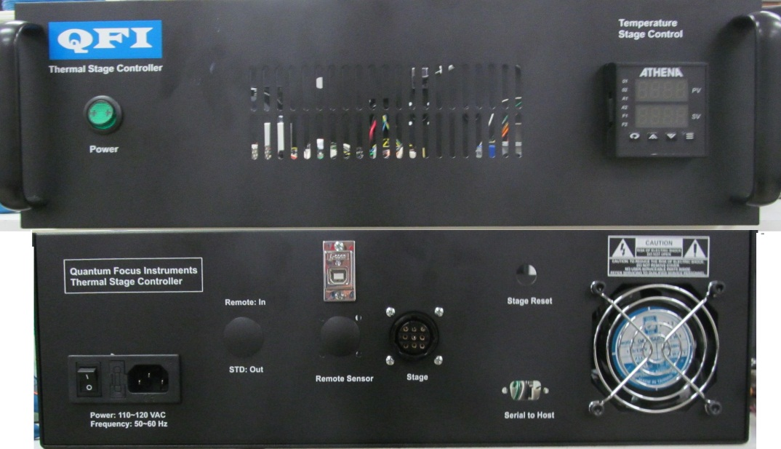

**Parts:**

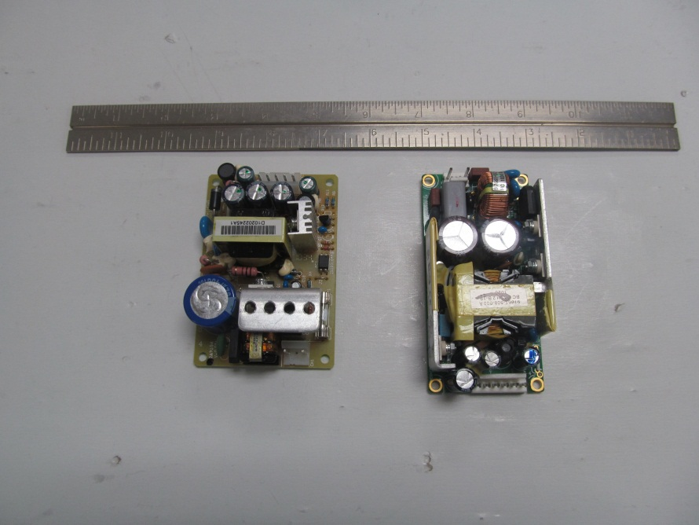

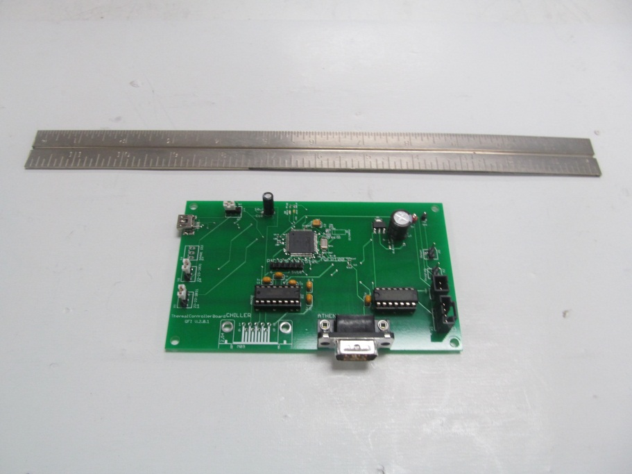

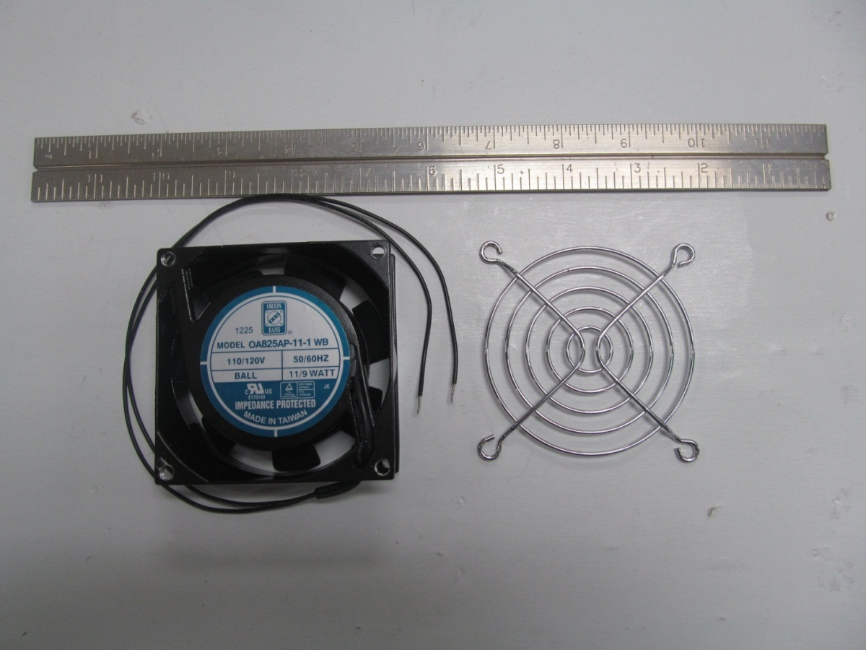

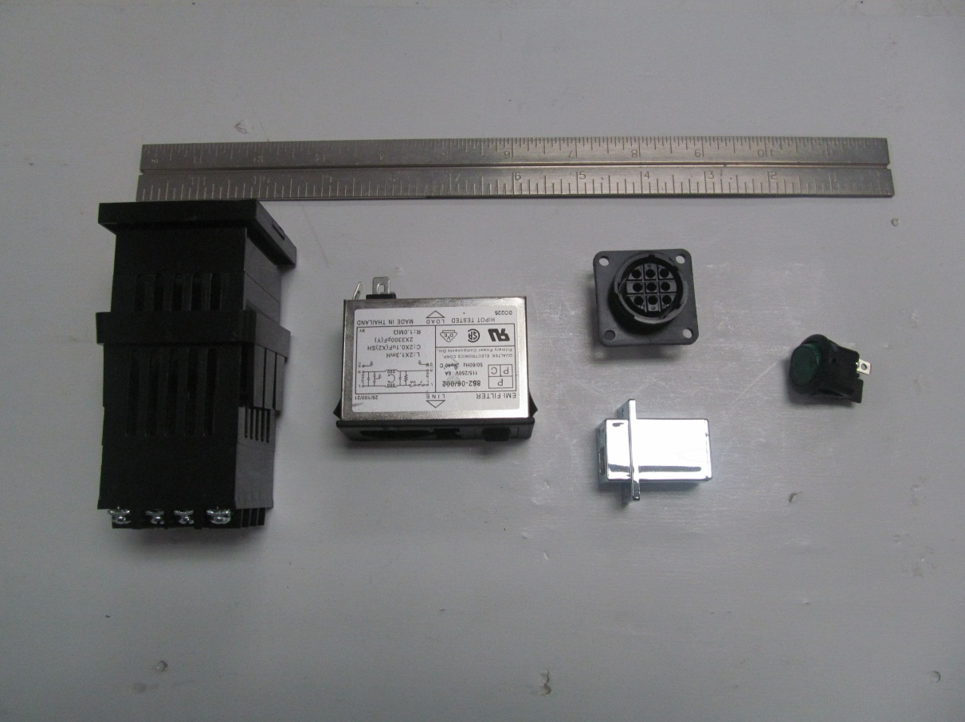

**Cables/Harnesses:**

**Stage Connector:**

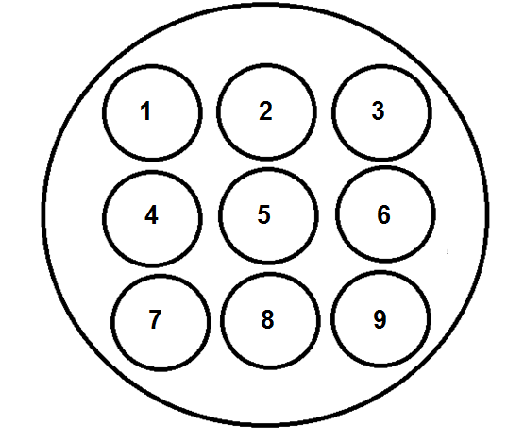

|  |  |  |  |  |  |
| --- | --- | --- | --- | --- | --- |
| Stage Connector | Gauge | Color | Length | Description | Termination |
| 1 | **24** | **Green** | **30”** | **RTD+** | **Fork Terminal 6** |
| 2 | **24** | **Yellow** | **30”** | **RTD-** | **Fork Terminal 6** |
| 3 | **24** | **Brown** | **30”** | **RTD-** | **Fork Terminal 6** |
| 4 | **16** | **Black** | **11”** | **Stage V-** | **Solder J3 “Cool”** |
| 5 | **24** | **Blue** | **11”** | **Ground Return (activate 9v Fan)** | **.100 J7 pin 3** |
| 6 | **16** | **Green** | **5”** | **Ground** | **MTA .156 J13 pin 3** |
| 7 | **16** | **Red** | **11”** | **Stage V+** | **Solder J3 “Heat”** |
| 8 | **20** | **Black** | **7”** | **9V Ground** | **MTA .156 2/2** |
| 9 | **20** | **Yellow** | **7”** | **9V** | **MTA .156 1/2** |

**Athena AC:**

|  |  |  |  |  |
| --- | --- | --- | --- | --- |
|  | Gauge | Color | Length | Termination |
| .100 pin 1/2 | **24** | **Black** | **32”** | **Fork Terminal 6** |
| .100 pin 2/2 | **24** | **White** | **32”** | **Fork Terminal 6** |

**12V AC:**

|  |  |  |  |  |
| --- | --- | --- | --- | --- |
|  | Gauge | Color | Length | Termination |
| MTA .156 1/3 | **16** | **Black** | **13”** | **Terminal 8** |
| MTA .156 2/3 | **16** | **White** | **13”** | **Terminal 8** |
| MTA .156 3/3 | **16** | **Green** | **13”** | **Terminal 8** |

**AC Input:**

|  |  |  |  |  |
| --- | --- | --- | --- | --- |
|  | Gauge | Color | Length | Termination |
| MTA .156 1/3 | **16** | **Black** | **19”** | **Spade Plug** |
| MTA .156 2/3 | **16** | **White** | **19”** | **Spade Plug** |
| MTA .156 3/3 | **16** | **Green** | **19”** | **Spade Plug** |

**5V to Microprocessor:**

|  |  |  |  |  |
| --- | --- | --- | --- | --- |
|  | Gauge |  | Length | Termination |
| .100 1/2 | **24** | **Red** | **16”** | **.100 1/2** |
| .100 2/2 | **24** | **Black** | **16”** | **.100 2/2** |

**5/12V AC:**

|  |  |  |  |  |
| --- | --- | --- | --- | --- |
|  | Gauge | Color | Length | Termination |
| MTA .156 1/3 | **16** | **Black** | **16”** | **MTA .156 3/3** |
| MTA .156 2/3 | **16** | **White** | **16”** | **MTA .156 1/3** |

**AC Switch:**

|  |  |  |  |  |
| --- | --- | --- | --- | --- |
|  | Gauge | Color | Length | Termination |
| MTA .156 1/3 | **16** | **Black** | **18”** | **Spade Plug** |
| MTA .156 2/3 | **16** | **Black** | **18”** | **Spade Plug** |
| MTA .156 3/3 | **16** | **White** | **18’** | **Spade Plug** |

**Control Bits:**

|  |  |  |  |  |
| --- | --- | --- | --- | --- |
|  | Gauge | Color | Length | Termination |
| .100 1/4 | **24** | **Red** | **13”** | **.100 1/4** |
| .100 2/4 | **24** | **Orange** | **13”** | **.100 2/4** |
| - | **-** | **-** | **-** | **-** |
| .100 4/4 | **24** | **Black** | **13”** | **.100 4/4** |

**Athena RS232 Communication:**

|  |  |  |  |  |
| --- | --- | --- | --- | --- |
|  | Gauge | Color | Length | Termination |
| Female D9 2 | **24** | **Orange** | **25”** | **Fork Terminal 6** |
| Female D9 3 | **24** | **Red** | **25”** | **Fork Terminal 6** |
| Female D9 5 | **24** | **Black** | **25”** | **Fork Terminal 6** |

**Athena Control Bits:**

|  |  |  |  |  |
| --- | --- | --- | --- | --- |
|  | Gauge | Color | Length | Termination |
| .100 1/4 | **24** | **Blue** | **25”** | **Fork Terminal 6** |
| .100 2/4 | **24** | **White** | **25”** | **Fork Terminal 6** |
| .100 3/4 | **24** | **Red** | **25”** | **Fork Terminal 6** |
| .100 4/4 | **24** | **Black** | **25”** | **Fork Terminal 6** |

**9V:**

|  |  |  |  |  |
| --- | --- | --- | --- | --- |
|  | Gauge | Color | Length | Termination |
| MTA .156 1/2 | **20** | **Yellow** | **8”** | **MTA .156 1/6** |
| MTA .156 2/2 | **20** | **Black** | **8”** | **MTA .156 3/6** |

**AC 9V**

|  |  |  |  |  |
| --- | --- | --- | --- | --- |
|  | Gauge | Color | Length | Termination |
| .156 pin 1/3 | **16** | **Black** | **8”** | **Terminal 8** |
| .100 pin 3/3 | **16** | **White** | **8”** | **Terminal 8** |

**5/12V:**

|  |  |  |  |  |
| --- | --- | --- | --- | --- |
|  | Gauge | Color | Length | Termination |
| MTA .156 1/3 | **20** | **Red** | **15”** | **MTA .156 4/5** |
| MTA .156 2/3 | **20** | **Orange** | **15”** | **MTA .156 1/5** |
| MTA .156 3/3 | **20** | **Black** | **15”** | **MTA .156 2/5** |

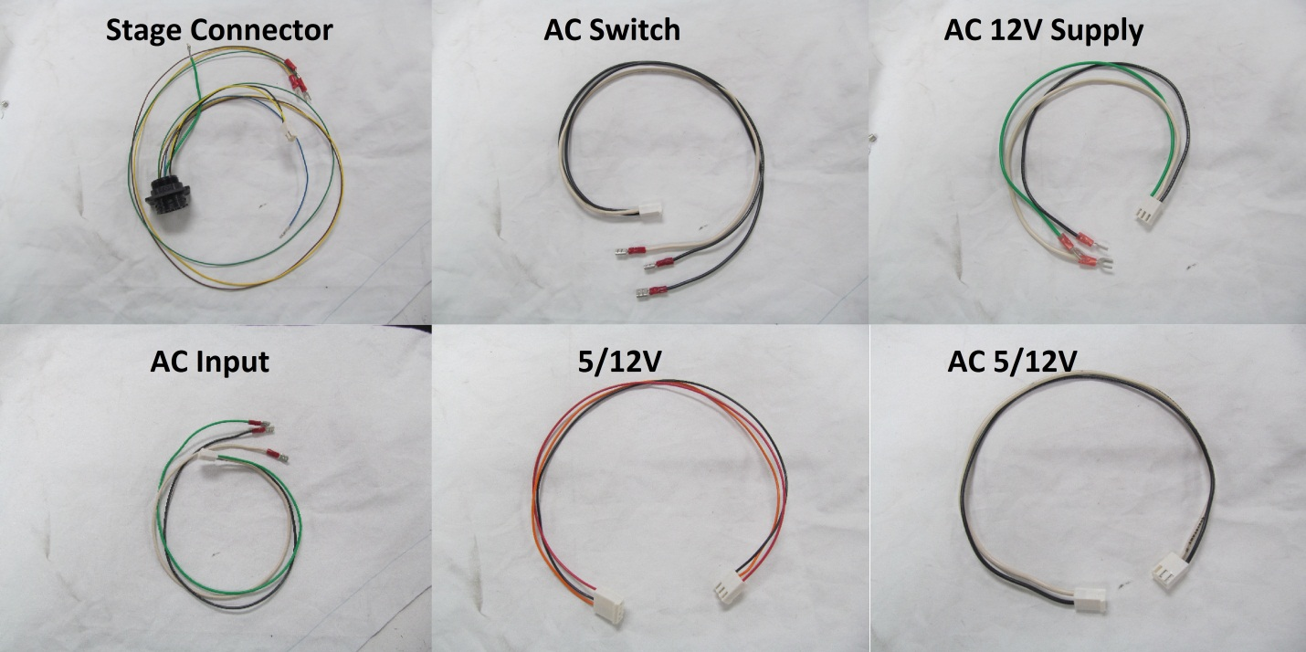

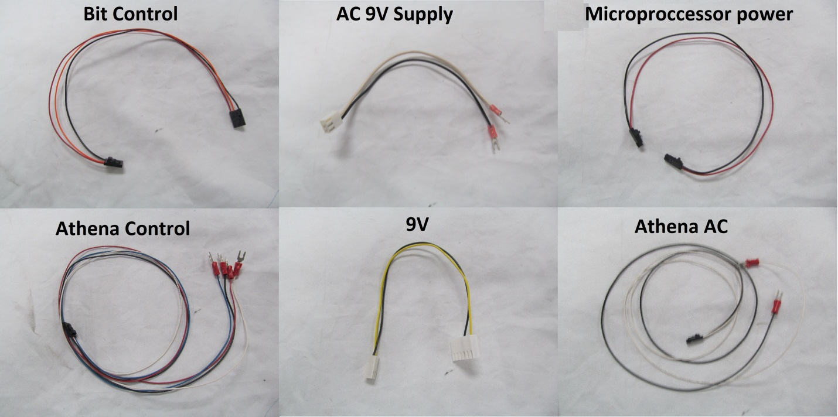

**Relay Board:**

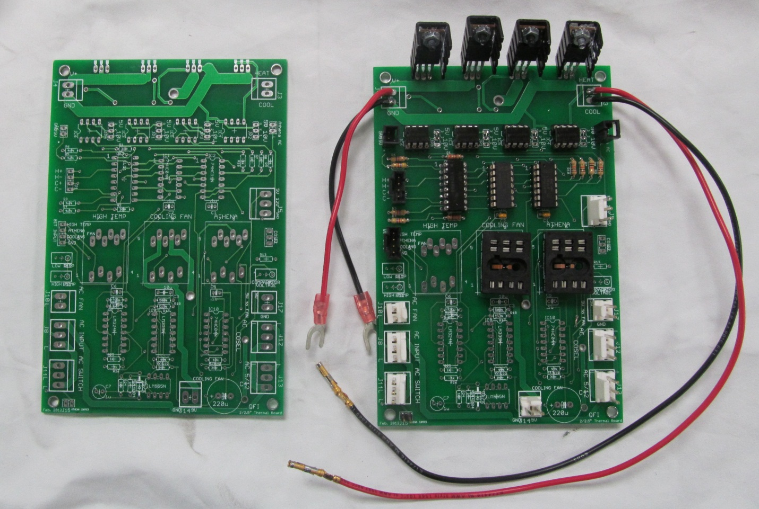

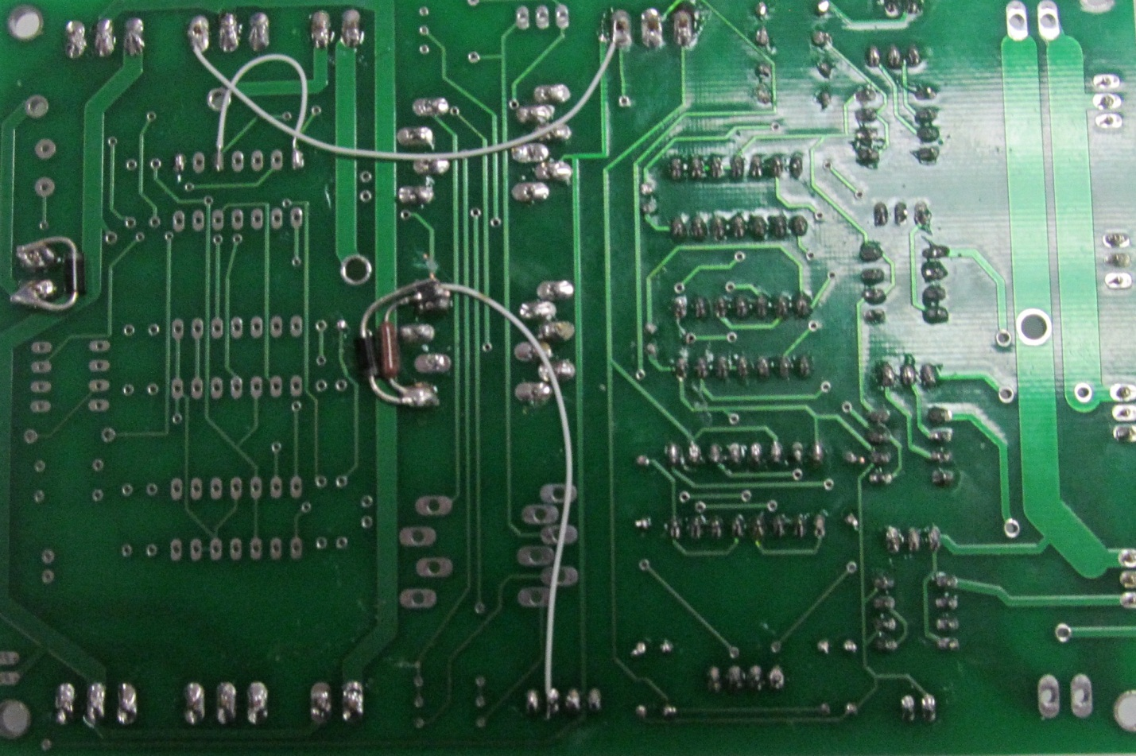

Modifications: (Revision 1 Modifications are not needed on Revision 2)

* Add two 15V Zener diodes one over the fan TTL(Pin1 And Pin4) relay and one over the Fan 9V(pin1 and pin2).
* Add a 1k Ohm resistor over the TTL relay (Pin 1 and Pin 4)
* Wire connections as shown

**Athena Wiring:**

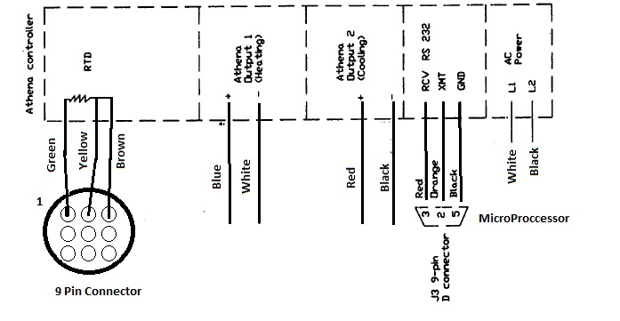

* All wires are 24 gauge

**Microcontroller PCB:**

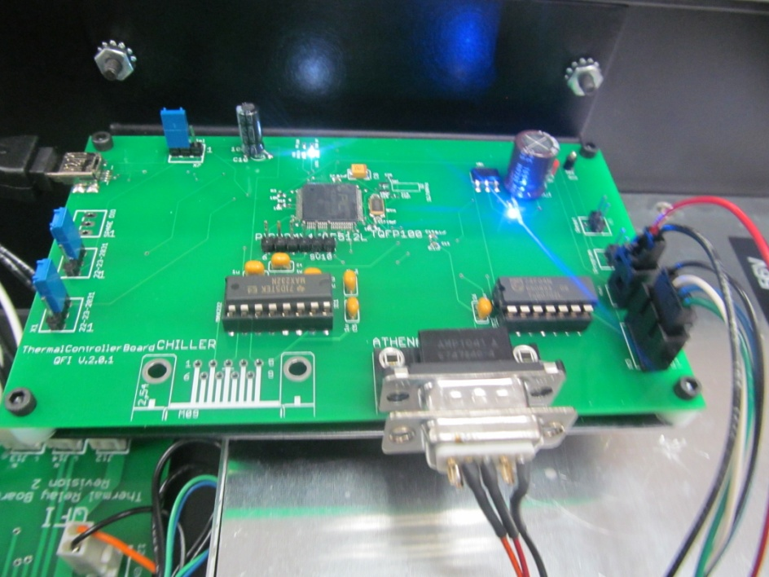

* Program the Bootloader onto the Microprocessor via Pickit3
* Program the UBW32 program onto the Microprocessor via USB.
* These steps are explained in Thermal Stage Firmware Tutorial.
* Connect three jumpers as shown in the picture
* Pin 2 of the D9 connector connects to XMT of the Athena. Pin 3 of the D9 connector connects to RCV of the Athena. Pin 5 of the D9 connects to GND of the Athena

**Side Notes:**

* **Slide Slider switch on 12V supply to 115VAC. (230VAC default)**
* The AC fan needs to be tapped for 10-32 screws.
* Connect a fan to the side panel to continuously blow air on the H-Bridge FETS.
* The microprocessor will shut off the system controller if the Athena does not respond. Once the communication issue is resolved the power switch must be toggled to bring the system back. **The power must be in the off position for at least 10 seconds to insure the firmware will reset correctly.**